**Project Documentation**

**Project Title:** Hackathon Poster Design – SPHERE Coding Club  
**Group Number:** 3  
**Team Members:**

1. Siddheshwar Hing
2. Sanjay Kushwaha
3. Sanskruti Jagdale

**Submission Date:** 24/10/2025  
**Submitted To:** Shreyash Atre, **anish mogam**  
**Project Type:** Digital Poster Design (Canva)

**1️. Introduction**

The **SPHERE Coding Club** assigned our team the task of designing a **digital poster** to promote the upcoming **Hackathon 2025** event. A hackathon is an innovative competition that inspires students to create new ideas and technical solutions. Through this poster, our goal was to encourage participation, highlight creativity, and represent the coding spirit of the event through an appealing visual design.

**2️. Objectives**

* To design a professional and attractive Hackathon poster
* To promote the SPHERE Coding Club event within the college
* To apply design skills using Canva tools
* To collaborate and work effectively as a team
* To learn visual design principles such as font hierarchy, layout, and alignment

**3️. Tools and Technologies Used**

* Canva (Poster Design)
* Google Forms (Event Registration)
* QR Code Generator
* Laptop/Desktop
* chatGpt

**4**. **Project Overview**

* This project focused on creating a visually impactful **Hackathon poster** assigned by SPHERE Coding Club. Each member contributed different skills such as content writing, layout design, and reviewing. The final poster includes the club name, event title, technology-related theme, and a powerful tagline to attract participants and promote innovation.

5️. **Daily Progress Summary**

| **Date** | **Work Done** |
| --- | --- |
| 18th October | Siddheshwar and Sanjay conducted a meeting for poster concept and planning |
| 21st October | Siddheshwar and Sanskruti discussed modifications and design improvements |
| 23rd October | All team members worked together on designing, editing and reviewing the poster |

**Work Division for Hackathon Poster Projec**t

| **Member** | **Name** | **Tasks Assigned** |
| --- | --- | --- |
| Member 1 | **Sanskruti Jagdale** | - Write the poster title, tagline, and short description- Create meaningful content related to hackathon theme- Ensure text is grammatically correct and clear |
| Member 2 | **Siddheshwar Hinge** | - Design the Hackathon poster using Canva- Arrange text and visuals in a balanced layout- Ensure creativity, readability, and presentation quality |
| Member 3 | **Sanjay** | - Review final alignment, spacing, and content accuracy- Select color scheme, fonts, tech symbols- Add QR code / logo and ensure professional finishing touches |

**• All members discuss themes, colors, and tagline together before starting.**

**• Each member gives suggestions during design and review stages.**

**• Final decision is taken collectively for better creativity and fairness.**

6️⃣ **Screenshots**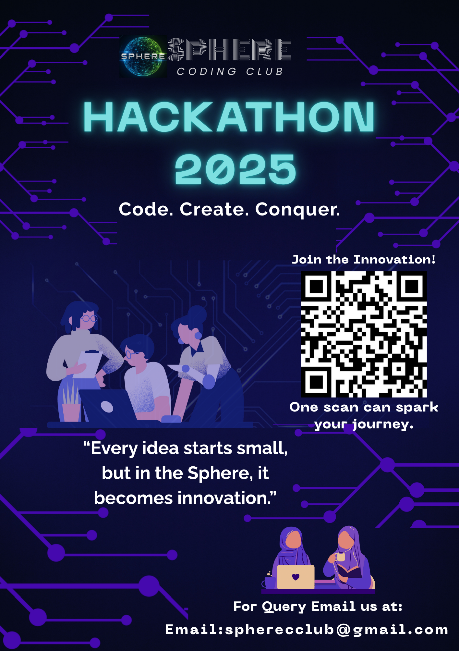

**7️. Learnings and Challenges**

**Learnings**

* Improved design knowledge using Canva
* Better teamwork and communication
* Learned about visual composition and poster branding

| **Challenges** | **Solutions** |
| --- | --- |
| Choosing the perfect theme and color | Finalized after group discussion |
| Balancing content and images | Adjusted alignment and font sizes |
| Managing schedules for meetings | Coordinated with group messaging |

**8️. Conclusion**

This project, assigned by SPHERE Coding Club, gave us the opportunity to apply our design and creative skills to a real-world event. We developed a poster that effectively represents the hackathon theme and promotes student participation. The experience strengthened our teamwork, design knowledge, and confidence in digital creation.

**Final Note**

We sincerely thank **SPHERE Coding Club**, our mentor **Shreyash Atre , anish mogam**,and all team members for their support and collaboration. This task was a valuable learning experience in creativity, communication, and teamwork.